YLDP Session 3 at Houston Food Bank

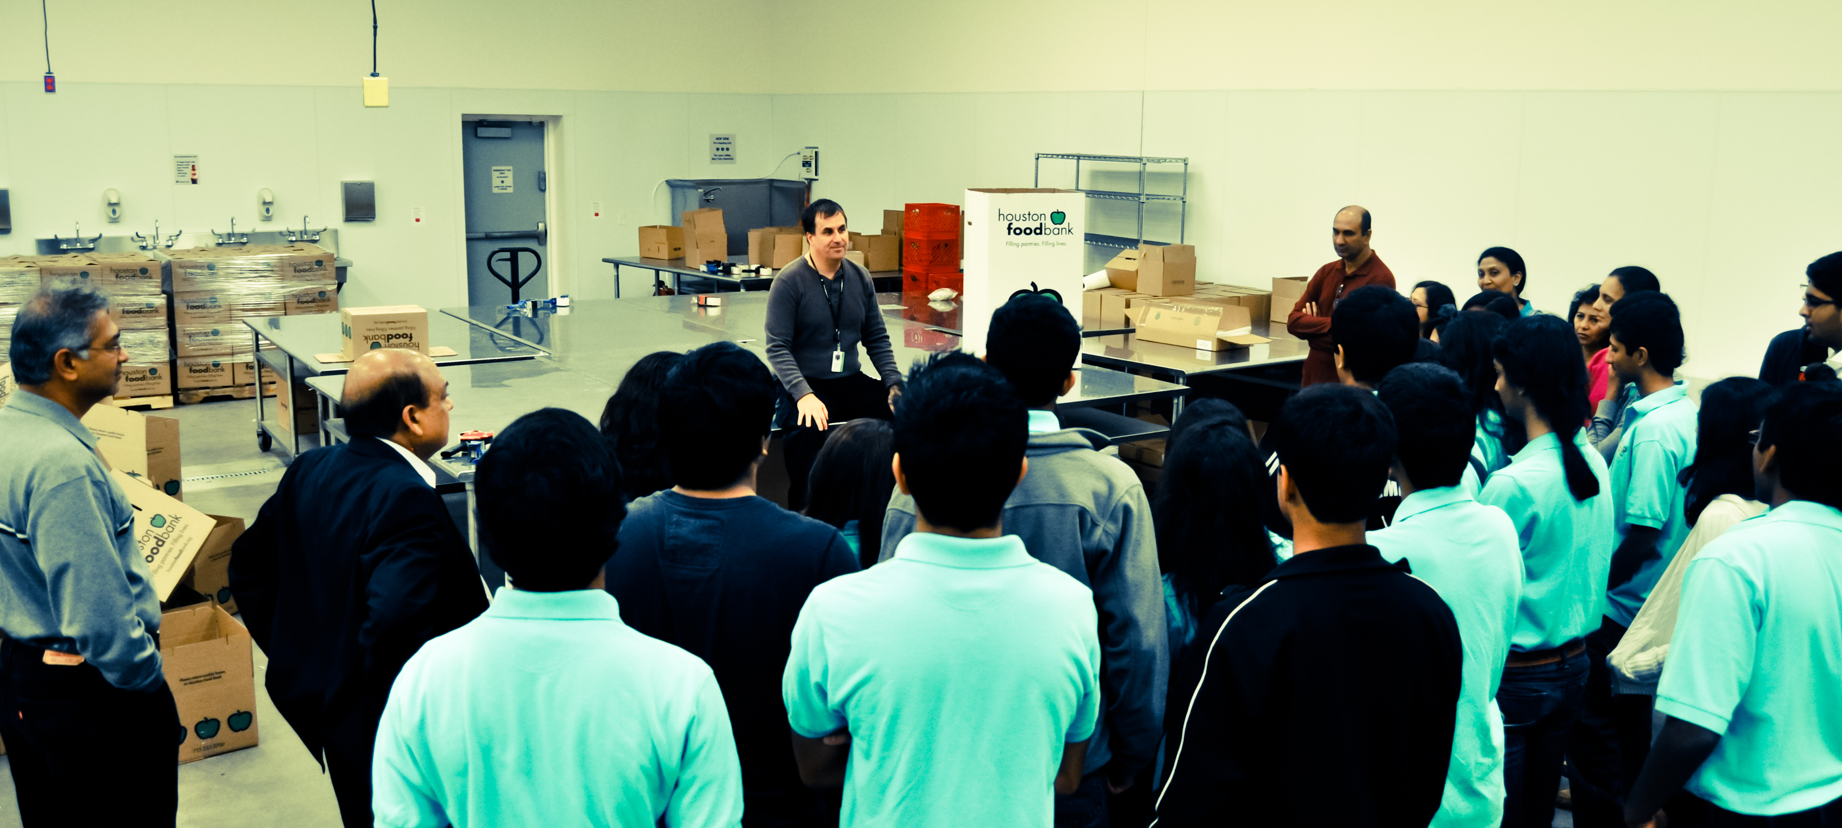

On Saturday, December 17, 2011, the YLDP of Houston met at the Houston Food Bank for its third classroom session on charity and philanthropy. The students took a tour of the new facility and heard from the CEO, Mr. Brian Greene.
The Houston Food Bank is a non-profit organization that provides food to nearly 500 hunger-relief programs in the Houston area and feeds approximately 865,000 people yearly. During the tour the YLDP students got to see the product recovery room, the repacking room, and the warehouse. All students were amazed when they learned that one-hour of volunteering can prepare about $75 of donations.
Mr. Greene exemplified several traits that are essential to good leaders; selflessness, courage, and perseverance to name a few. However, the trait that stood out the most for us was his passion. He had a strong will to fight hunger and homelessness in Houston, this commitment to his cause lead to the strong passion that he possesses today. All students learned that having passion for your cause brings power to your words and gives you the ability to manage and lead a group of individuals. Being able to lead a large group is especially important at non-profit organizations such as the food bank where everyone is a volunteer and doesn’t receive wages in return for their services. Mr. Greene taught everyone that being a leader means nothing without a team to lead.
Following the tour, students discussed the importance of charity and philanthropy in leadership. At the end, students were motivated to start their own food drives in order to collect more donations for the food bank. In addition, the students committed to bringing a few donations to each of their sessions so that the food could be collected and donated in bulk to the Houston Food Bank.
YLDP students Anuva Kachru, Akshay Rajan, Adarsh Nednur, Harsha Rao, Priya Bhattacharjee contributed to this article

